CCC-632 Data Analytics for Societal Applications

Project II: Role of Data Analytics Towards Building of Smart Cities

Authors - Agastya Seth

(1610110047)

Ishaan Malhotra

(1610110152)

Karan Asrani

(1610110485)

Suyash Singh

(1610110390)

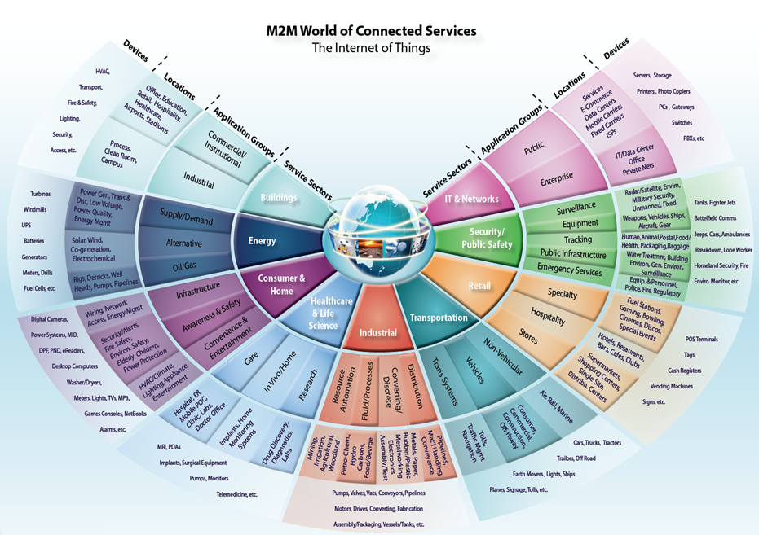

Case Study: Big Data Analytics in Internet of Things

**Brief Introduction**

**What is big data analytics?**

On a broad scale, data analytics technologies and techniques provide a means to analyze data sets and draw conclusions about them to help organizations make informed business decisions.

Once the data is ready, it can be analyzed with the software commonly used for advanced analytics processes. That includes tools for data mining, which sift through data sets in search of patterns and relationships; predictive analytics, which build models to forecast customer behavior and other future developments.

**What is IoT?**

* The **Internet of Things** (**IoT**) is the network of physical objects—devices, vehicles, buildings and other items embedded with electronics, software, sensors, and network connectivity—that enables these objects to collect and exchange data.

**Importance:**

The IoT promises to make our environment -- our homes and offices and vehicles -- smarter, more measurable, and chattier.

* Smart speakers like Amazon's Echo and Google Home make it easier to play music, set timers, or get information.
* Home security systems make it easier to monitor what's going on inside and outside, or to see and talk to visitors
* Looking beyond the home, sensors can help us to understand how noisy or polluted our environment might be. Autonomous cars and **smart cities** could change how we build and manage our public spaces. In all, IoT is one big leap towards the goal of automation.

Big Data Analytics in Internet of Things

The Motivation

The IoT generates vast amounts of data: from sensors attached to machine parts or environment sensors, or the words we shout at our smart speakers. That means the IoT is a significant driver of big data analytics projects because it allows companies to create vast data sets and analyze them.

Giving a manufacturer vast amount of data about how its components behave in real-world situations can help them to make improvements much more rapidly, while data culled from sensors around a city could help planners make traffic flow more efficiently. In particular, the IoT will deliver large amounts of real-time data.

Big Data Analytics enables the move from IoT to real-time control, which is desired for many SCC (Socially Connected Communities) applications. In the era of IoT, SCC features the deployment of multitude of wireless sensors and agents spanning many application domains including: environmental, healthcare, smart interconnected automobiles and trucks, and smart buildings.

Current Challenges

1) Data Heterogeneity

Typically the data relevant to SCC are very heterogeneous. For example, data for smart buildings include not only outdoor-weather data and energy-consumption data, but also data on the state of doors and windows, thermostat settings, HVAC operational parameters, airflows, room occupancy, building structure and materials, among others.

2) Decision Making Under Uncertainty

There are many sources of uncertainty which must be considered carefully in decision-making. First, our understanding of many issues facing cities is incomplete; second, we often lack the data needed to specify the boundary conditions with sufficient accuracy. We must improve decision making under uncertainty by understanding assessment, representation and propagation of uncertainty, developing robust-optimization methods, and designing optimal sequential decision making.

Methodology

1. *Determining the potential problems*

* Asking the concerned authorities like the Ministry of power, Ministry of infrastructure development about the problems that may arise while building/converting to smart city.
* This way, the procedure to setting up a smart city would be narrowed down to a set of methods that is best suited to the city in interest and the implementation time would also be reduced.

1. *Short listing a set of cities*

* The cities which require the least time and cost of implementation (for example, cities which already have a developed infrastructure that they only require a few more steps to build a smart city), will be funded by the government to make them smart cities.
* This will help in the fabrication of a smart city, from the scratch, which share similar demographics to a smart city that is built previously.

1. *Public-private partnerships*

* Incentivising schemes provided to private companies to build a smart city.
* Setting deadlines to meet the targets.

1. *Determining the key drivers and barriers*

* Promoting the factors that help in driving a developing smart city to a complete smart city. For example, if the smart traffic lights gave a boost to the social welfare when a smart city was being built, the government can further incentivise the consumers and the manufacturers to make all the traffic lights smart ones.
* Eliminating the factors that act as barriers to the development of smart cities. For example, if a large amount of data is being generated by the sensors and all the data is being stored for a period of time, it may lead to a skyrocket demand by a developing smart city for the storage units and it may not possible to manage all of it in the short-run. So, either the period of time that is currently being used can be lowered and the demand will not be as high as it previously was or only the data which is necessary can be stored for the initial period of time while all other data gets automatically erased after a few days.

Possible Improvements

Impact

1. Smart Homes: For consumers, the smart home is probably where they are likely to come into contact with internet-enabled things, and it's one area where the big tech companies (in particular Amazon, Google, and Apple) are competing hard. The most obvious of these are smart speakers like Amazon's Echo, but there are also smart plugs, light bulbs, cameras, thermostats, and the much-mocked smart fridge.
2. Smart Cities: By spreading a vast number of sensors over a town or city, planners can get a better idea of what's really happening, in real time. As a result, smart cities projects are a key feature of the IoT. Cities already generate large amounts of data (from security cameras and environmental sensors) and already contain big infrastructure networks (like those controlling traffic lights). IoT projects aim to connect these up, and then add further intelligence into the system.

Big tech companies see smart cities projects as a potentially huge area, and many -- including mobile operators and networking companies -- are now positioning themselves to get involved.